Binary Classification
CSC 272 - Machine Learning

Aum Hirpara and Altaf Shaik

Abstract: In this research, we use two datasets, the Titanic and the Breast Cancer Wisconsin (Diagnostic) dataset, to investigate the nuances of binary categorization. The main goal is to compare the effectiveness of four well-known machine learning algorithms: Logistic Regression, Decision Tree, K-Nearest Neighbors (KNN), and Perceptron. To guarantee the quality and usefulness of the datasets, the study starts with data pre-processing procedures. Next, the chosen algorithms are implemented. To maximize model performance, hyper parameter tweaking is carried out, and several studies are carried out to comprehend the influence of training dataset size and computing efficiency.
As can be seen from the findings, each method has advantages and disadvantages. Decision Trees work particularly well at collecting intricate patterns in both datasets. The significance of feature selection, interpretability of the model, and the impact of class imbalance on model performance are emphasized in the study. The project's insights can guide future investigations into binary categorization, opening the door to more advanced machine learning applications in practical settings. The results highlight the need of thorough assessment in obtaining precise forecasts and streamlining machine learning processes.

1. Introduction: In the data-driven world of today, machine learning is essential to making wise judgements in a variety of fields. Binary classification is a core job in machine learning, where the goal is to classify examples into one of two unique classes. By putting several machine learning algorithms into practice and examining them, this research aims to address the difficulties and subtleties of binary categorization.
Two exciting binary classification problems are presented by the Titanic and the Breast Cancer Wisconsin (Diagnostic) datasets, which we shall analyses in this work. Using this approach, we want to evaluate and compare the performance of four popular machine learning algorithms: Decision Tree, K-Nearest Neighbors (KNN), Perceptron, and Logistic Regression. By detailing our procedures, findings, and observations, the study will shed light on how these algorithms function in different situations.
2.Datasets:
1. Breast Cancer Wisconsin (Diagnostic) Dataset
The area of medical diagnostics makes extensive use of the Breast Cancer Wisconsin (Diagnostic) dataset. It consists of 569 examples with 30 traits that represent different aspects of the cell nuclei seen in breast cancer biopsies. The binary target variable indicates if the tumor is benign (B) or malignant (M). This dataset's characteristics are numerical and come from digital photos of specimens with breast masses. These features include:
- Radius Mean: The average distance from the center to points on the perimeter of the tumor.
- Texture Mean: The standard deviation of the gray-scale values.
- Perimeter Mean: The average perimeter length of the tumor.
- Area Mean: The average area of the tumor.

This dataset is especially intriguing since it represents a practical use of machine learning in the medical field, where increasing the precision of tumor identification has the potential to save lives. It also makes it possible to investigate the significance of features, the interpretability of models, and the effects of different algorithms on a crucial healthcare problem.

2. Titanic Dataset
An historical collection of data regarding the people who travelled on the tragic Titanic ship is called the Titanic dataset. 887 occurrences are included, along with a number of other variables including ticket class, demographic information, and survival status (0 = Not Survived, 1 = Survived). Principal attributes consist of:

- PassengerId: Unique identifier for each passenger.
- Pclass: Class of the ticket (1st, 2nd, or 3rd).
- Sex: Gender of the passenger.
- Age: Age of the passenger at the time of the voyage.
- Fare: The fare paid for the ticket.
This dataset is interesting because it depicts a situation in real life where survival was influenced by a number of variables, including gender, age, and socioeconomic status. Many studies have been conducted on the Titanic dataset, which is a great example of a test case for machine learning algorithms because of its rich historical context and variety of variables.

Pre-processing: For both datasets, we conducted essential pre-processing steps to ensure the quality and usability of the data:
- Handling Missing Data: To make the study easier, we decided to remove rows in the Titanic dataset that had missing values. This choice was taken with the understanding that more sophisticated imputation methods may be used in subsequent research in order to preserve data integrity. There were no missing values in the Breast Cancer dataset.
- Feature Scaling: To make sure that every input variable contributed equally to the distance calculations in algorithms such as KNN, we standardized the features. This was especially crucial for distance-based algorithms since different scales might cause findings to be skewed.
- Data Encoding: To make them compatible with machine learning techniques, categorical characteristics (such "Sex" in the Titanic dataset) were converted into numerical values.

Hypotheses: We made the following assumptions about the algorithms' performance based on the features of the two datasets:

Breast Cancer Dataset: Given the characteristics nature and logistic regression's linearity, we anticipated that this dataset would respond very well to the model. In addition, decision trees and KNN could work well because of their capacity to manage intricate interactions.

Titanic Dataset: Given their ability to capture the non-linear correlations included in the demographic data, tree-based techniques like Decision Trees and KNN were expected to perform well. Because of the non-linear nature of the interactions between the characteristics, Logistic Regression may not perform well on this dataset.

3. Methods: To evaluate the performance of the machine learning algorithms, we employed the following methods:
1.Train-Test Split: Using an 80-20 split, each dataset was separated into training and testing sets. In order to avoid overfitting, we were able to train the models on one portion of the data and assess their performance on a different fraction using this method.
2.Model Selection: We selected four algorithms for our analysis:
Decision Tree: A versatile algorithm that can model complex non-linear relationships by splitting the data into homogenous groups based on feature values.
K-Nearest Neighbors (KNN): A simple, instance-based learning algorithm that classifies instances based on the majority class of their nearest neighbors.
Perceptron: A type of linear classifier that updates its weights based on misclassifications during training.
Logistic Regression: A linear model used for binary classification that estimates probabilities using a logistic function.

4. Hyperparameter Tuning: For each algorithm, we performed hyperparameter tuning using GridSearchCV to identify the optimal settings. This process involved testing various hyperparameters and observing their effect on model performance. The following parameters were tuned:
Decision Tree: max_depth: Values ranging from 1 to 10.
KNN: n_neighbors: Values ranging from 1 to 20.
Perceptron: max_iter: Values ranging from 200 to 1000.
Logistic Regression: C: Values ranging from 10^-3 to 10^3.
Observations: The hyperparameter tuning results provided valuable insights into each algorithm's behavior:
- Decision Tree: In both datasets, the training score increases significantly with depth, while the cross-validation score does not increase as sharply. This indicates overfitting, where the model learns the training data too well and performs poorly on unseen data.
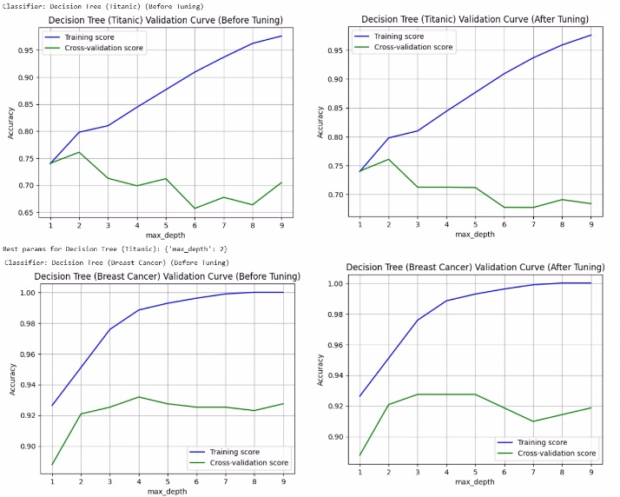Figure 1: Decision Tree

After Tuning show improvements in cross-validation scores, suggesting that hyperparameter tuning (like adjusting the maximum depth of the tree) helps to balance model complexity and generalization. Overall, the model demonstrated substantial improvements in accuracy as max_depth increased, indicating that deeper trees captured more complexity. However, overfitting became apparent with excessively deep trees.
- K-Nearest Neighbors: In both datasets, the training score decreases while the cross-validation score fluctuates. This suggests that as the model complexity changes with the number of neighbors, it may overfit the training data, especially at lower neighbor counts.
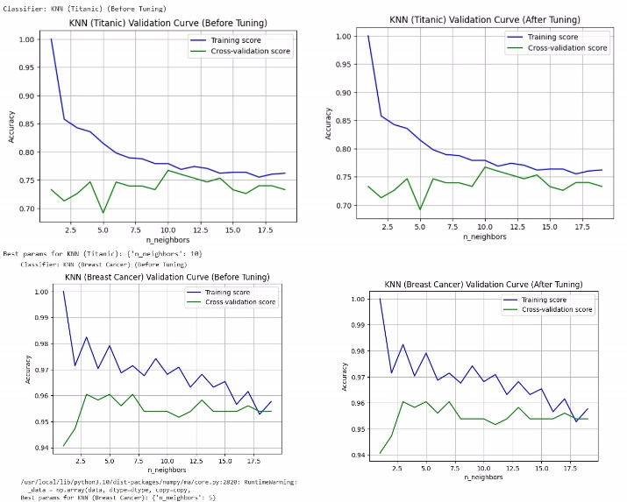
Figure 2: K-Nearest Neighbors
The graph illustrates hyperparameter tuning (adjusting the number of neighbors) can lead to better cross-validation performance, enhancing the model's ability to generalize. Overall, As the number of neighbors increased, the model's accuracy improved initially before stabilizing. This suggested that while more neighbors can provide a more generalized prediction, too many can dilute the decision boundary.
- Perceptron: Observing both datasets data, the training score tends to remain stable as the maximum iterations increase, but the cross-validation score's fluctuations indicate variability in performance on unseen data.
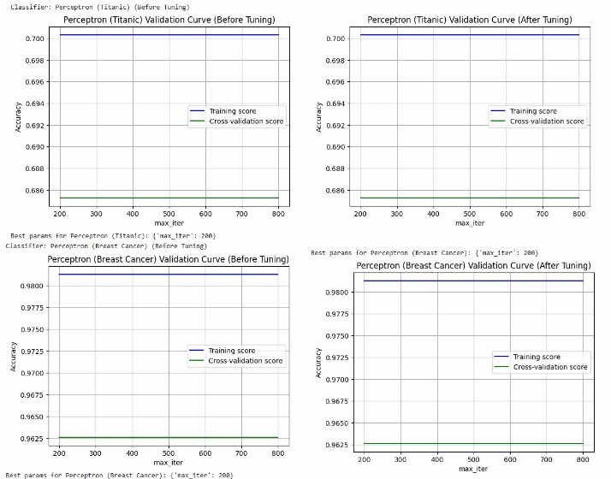

Figure 3: Perceptron
The tuning process helps to find the optimal number of maximum iterations that balances training and validation performance, leading to improved generalization. Monitoring both training and cross-validation scores is crucial for understanding the model's behavior and helps in making informed decisions on hyperparameter adjustments. Overall, the accuracy improved as we increased the number of iterations. However, it reached a plateau beyond a certain point, indicating diminishing returns on computational resources.
- Logistic Regression: The initial graphs indicate potential overfitting if the training score is much higher than the cross-validation score. The goal is to find a balance where both scores are high and close together.

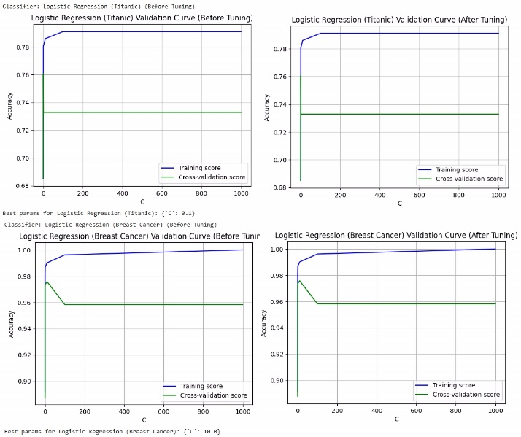
Figure 4: Logistic Regression
The C parameter is crucial for controlling the degree of regularization. Finding an optimal C helps to reduce overfitting and improve the model's ability to generalize. The divergence between training and cross-validation scores serves as an important diagnostic tool. A large gap suggests that the model is too complex for the data, while a smaller gap with high scores indicates a well-tuned model. Overall, the performance fluctuated with the C parameter. A lower value of C resulted in more regularization, which improved generalization but may lead to underfitting. Conversely, high values could cause overfitting.
- Other Analyses:
- Training Dataset Size Effects: To further explore how the size of the training dataset impacted model performance, we conducted experiments with different proportions of training data (e.g., 60-40, 70-30). This analysis revealed interesting trends:
- Breast Cancer Dataset: As the training set size increased, model accuracy consistently improved, demonstrating that more data provides better learning opportunities.
- Titanic Dataset: The results were mixed; while larger training sets generally improved performance, specific models like KNN experienced diminishing returns beyond a certain size due to their reliance on the local neighborhood.
- Training/Testing Timing Analysis: We also performed a timing analysis to compare the computational efficiency of each algorithm. The results indicated that:
The plots are shown below for before tuning and after tuning:

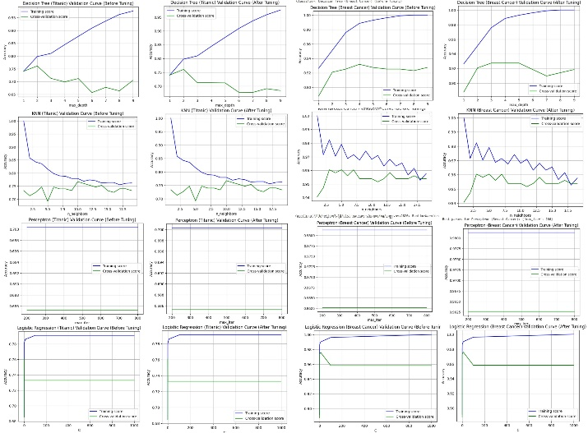

Figure 5: Plots Before & After Tuning
- Decision Trees fell somewhere in between, with reasonable training times but potential for longer inference times as the tree depth increased.
- KNN exhibited significantly longer training times as the dataset grew, particularly because it requires distance calculations for all instances.
- Perceptron and Logistic Regression were the fastest to train, making them suitable for large datasets.

- Results: After optimizing the hyperparameters, we summarized the final results of each algorithm in a table:

Classifier Model | Accuracy Before Tuning | Accuracy After Tuning | Training Time Before | Training Time After
Decision Tree (Titanic) | 0.7027027027027027 | 0.8108108108108109 | 0.0026369094848632812 | 0.00866246223449707
Decision Tree (Breast Cancer) | 0.9473684210526315 | 0.9385964912280702 | 0.038393259048461914 | 0.01912689208984375
KNN (Titanic) | 0.7297297297297297 | 0.7567567567567568 | 0.0064220428466796875 | 0.002529144287109375
KNN (Breast Cancer) | 0.9473684210526315 | 0.9473684210526315 | 0.002472400665283203 | 0.0024683475494384766
Perceptron (Titanic) | 0.5405405405405406 | 0.5405405405405406 | 0.0033004283905029297 | 0.002863645553588867
Perceptron (Breast Cancer) | 0.9736842105263158 | 0.9736842105263158 | 0.005301952362060547 | 0.004266023635864258
Logistic Regression (Titanic) | 0.7297297297297297 | 0.7297297297297297 | 0.0053234100341796875 | 0.004852294921875
Logistic Regression (Breast Cancer) | 0.9736842105263158 | 0.9736842105263158 | 0.02006220817565918 | 0.03902435302734375

- Discussion
- Performance Comparison
Based on the results, we observed that:

- The Decision Tree algorithm excelled in both datasets, showcasing its flexibility in modeling complex patterns.
- KNN delivered competitive accuracy, particularly in the Breast Cancer dataset, but suffered in the Titanic dataset due to the challenges of local density estimation.
- Perceptron performed decently but was less effective in comparison to other algorithms, particularly in datasets with non-linear relationships.
- Logistic Regression showed reliable performance in the Breast Cancer dataset, benefiting from its linear nature.
Insights and Interpretations
- Feature Importance: In the Breast Cancer dataset, analyzing feature importance through the Decision Tree model highlighted the most influential features for classifying tumors. For instance, features like radius and texture significantly contributed to accurate predictions.
- Class Imbalance: Both datasets exhibited some level of class imbalance, particularly the Titanic dataset. Future work should include some techniques to balance the classes, improving model performance.
- Model Interpretability: Decision Trees provided the most intuitive and interpretable results, allowing stakeholders to understand the decision-making process. In contrast, models like KNN and Logistic Regression were less interpretable.
- Limitations: This analysis had certain limitations, such as the simplistic approach to missing data in the Titanic dataset and the lack of consideration for ensemble methods that could potentially enhance performance.
8. Conclusion: To sum up, this study offered a thorough investigation of binary classification by utilizing a variety of algorithms on the Titanic and Breast Cancer Wisconsin datasets. We learnt a great deal about the advantages and disadvantages of Decision Tree, KNN, Perceptron, and Logistic Regression by analyzing their performance. In order to get accurate predictions, the study reaffirmed the need of thorough data pre-processing, hyperparameter tweaking, and model validation.
The knowledge acquired from this effort will provide the groundwork for next investigations and advancements in the field of binary classification as machine learning continues to develop. Our aim is to make a more significant contribution to the current discussion about efficient classification methods and their practical applications.

The lander begins each episode at the top center of the screen and is given a random initial force applied to its center of mass. The landing pad always remains at the same location, but the surface of the moon changes shape each episode. There are 4 actions that the agent can take, and a state space consisting of an 8-dimensional vector which are described in Figure 2 below.
Actions
Do Nothing
Fire Left Engine
Fire Main Engine
Fire Right engine

States
x position
y position
x velocity
y velocity
angle
angular velocity
left leg contact
right leg contact

Figure 2: Actions and States

All states are represented by continuous values, except for the two leg contact states which are boolean. The reward structure is based on various factors. Firing the main engine and the side engine generates rewards of -0.3 and 0.03 respectively.
Crashing on the surface leads to a reward of
-100 and landing safely earns a +100 reward. Each leg contacting the ground also receives a reward of +10 points. Finally, an episode terminates if the lander crashes, the lander goes outside the screen, or the agent lands on the surface.

- Algorithm/Model: In order to solve the Lunar Lander problem I chose to implement a Deep Q Network (DQN) inspired by the pseudocode below in Figure 3.

Figure 1: Screenshot of Lunar Lander 1
Environment

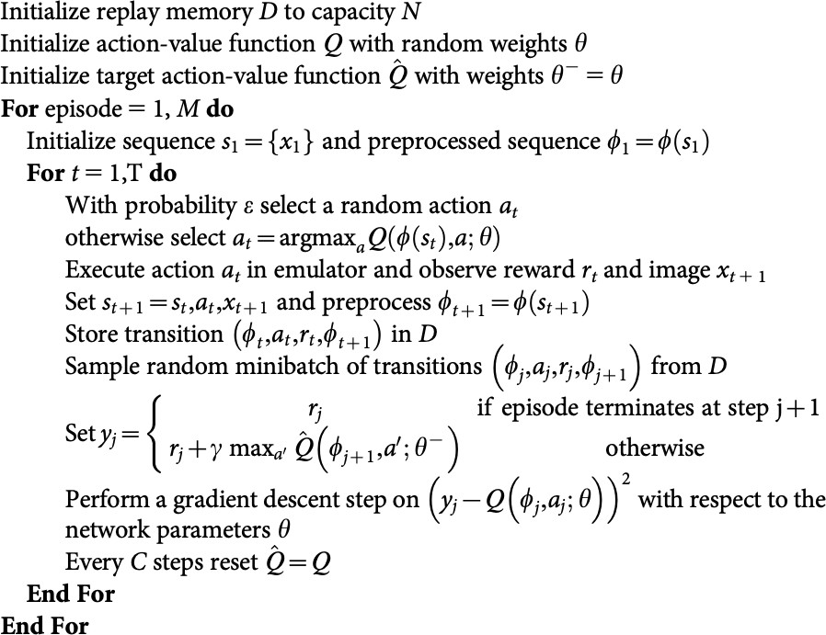

Figure 3: DQN Pseudocode

The main difference between DQN and more traditional reinforcement learning algorithms is that DQN uses a neural network to decide which action to take as opposed to a conventional Q-table. Since this problem does not have a finite state space (e.g. the state variables are continuous) using a Q- table would require potentially error introducing simplifications such as discretizing the state space, and I decided that it would be more useful to use a neural network in its place instead. Since a neural network is a non-linear function approximator it can essentially be used to learn any function, given enough hidden layers. Although many recent DQN papers use convolutional networks to directly extract information from the game screen to predict actions, I decided that this may be unnecessary, and decided to use a neural network with only fully connected layers that attempts to map a state to an action. I chose to use an architecture with two hidden layers, that takes an eight dimensional vector as input (the current state) and a four dimensional vector as output, where each output node represents the Q value of each action. The output node with the largest value would then correspond to the action that should be taken given the current state. Each hidden layer is constrained to be the same size, but the actual size is a hyperparameter that I will tune in the following sections. Below in Figure 4 I show the network architecture.

State Action

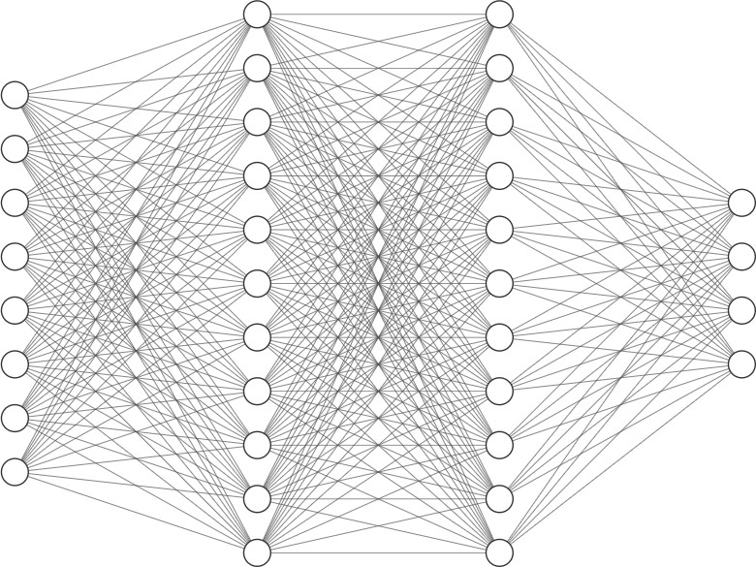
Figure 4: Neural Network Architecture

The simplest way to train a DQN would be to update the weights of the neural network after every time-step with the state, next state, and action values from that time-step in what is known as standard online Q- learning. However this has several disadvantages since there are strong correlations between consecutive samples, making training very inefficient. As a better approach I use what is known as experience replay. In this approach a replay buffer is created which stores a finite amount of state, action, next, state, reward experiences. The network is then only trained after a predefined set of time-steps, and is trained with a mini-batch of samples which are sampled uniformly at random from the replay buffer. Since we are randomly sampling from a buffer with a fixed size, this allows the network to be trained multiple times with the most recent experiences, which if the network is learning, will be more reward rich, leading to more efficient learning. Another important part of my implementation included actually two neural networks. Once which is used to make predictions, and one which is only used to the target action values. Every C time-steps all parameters in the target neural network are replaced with the parameters in the acton value prediction neural network. Since the targets will be computed using an older set of parameters this allows for a more stable learning process and helps prevent the likelihood of divergence and oscillation in performance.

4: Hyperparameter Optimization:

Hidden Layer Size

The first hyperparameter that I chose to explore is the hidden layer size. The neural network layer has two hidden layers which I arbitrarily constrained to be the same size for simplification purposes. In fully connected layers the hidden layer size determines how many parameters the network has to learn and represent, and therefore has a profound effect on the training and performance. A network with a small hidden layers size will be able to train and predict quickly due to the small amount of parameters, but may not be complex enough to model the complex non-linear relationship between the states and the actions. However, a network with too many parameters will take a very long time to train and predict, and also may overfit to the training data and be unable to generalize to new data. Below in Figure 5 I show the results of training for varying hidden layers sizes.

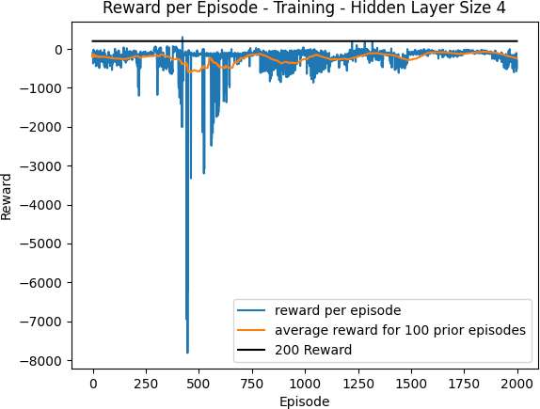
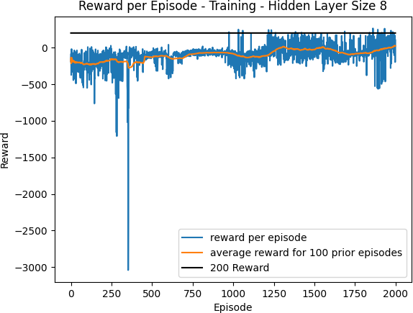
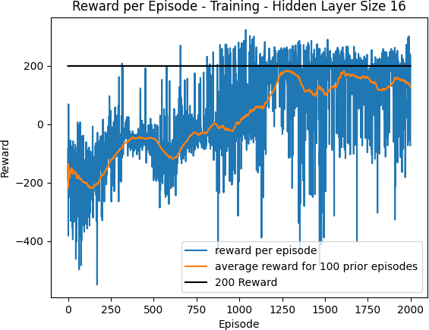
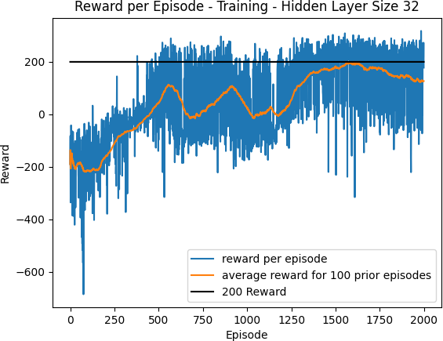
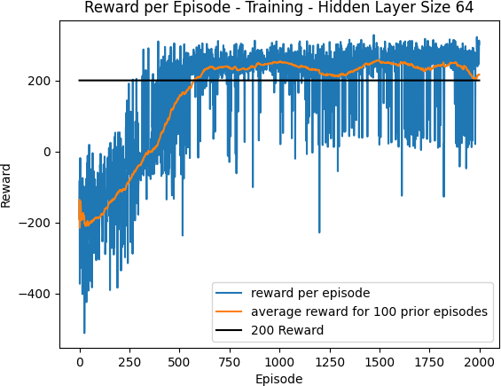
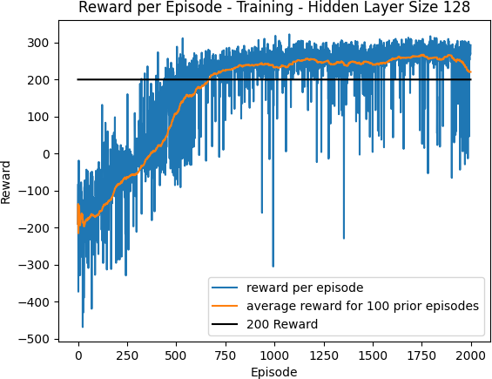

Figure 5: Hidden Layer Size Optimization

We can see from the training plots above that when the hidden layer size is too small (4,8,16), the DQN is unable to learn a policy
that meets the reward threshold of 200 after 2000 episodes. When the hidden layer size is increased to both 64 and 128 the reward threshold is met and becomes fairly stable after about 500 episodes. In the further experiments I will choose to go with the smaller hidden layer size of 64 since it uses significantly less parameters than the size of 128, and therefore takes less time to train and is less likely to overfit.

Epsilon Decay

Another important hyperparameter is the epsilon decay factor. I chose to use an epsilon greedy approach for choosing an action in order to allow the agent to both explore its environment by choosing random actions, but also leverage what has been learned already by using the Q neural network to choose an action. Since more exploration is needed earlier in the training I start epsilon at 1 so that it will always explore randomly, and then after each episode I decay epsilon by multiplying the current epsilon by some epsilon decay factor that is less than 1. I also set the minimum that epsilon can be to 0.1 so that the agent will always be allowed to explore even late in training so that it will be less likely to overfit. Below in Figure 6 I show the epsilon decay schedule for varying values of decay factors.
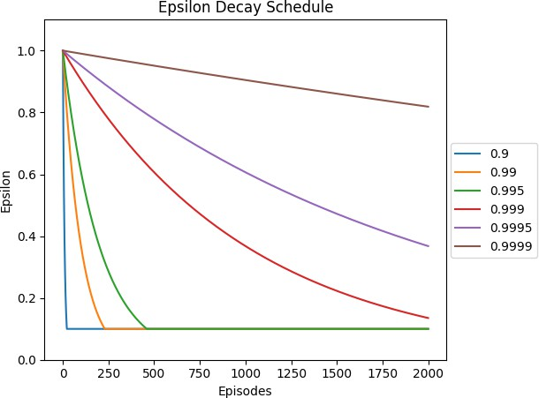

Figure 6: Epsilon Decay Schedules

Choosing this epsilon decay factor is a tradeoff. If the factor is too large, epsilon will decay very slowly, leading to too much random exploration and the agent could take a very large amount of episodes to learn.
However, if the epsilon decay is too small, epsilon will decay too quickly, and the agent will not have explored the environment enough to observe all the different reward

rich states. Below in figure 7 I show the results of training for the different values of epsilon decay, using the optimal hidden layer size of 64 found previously.
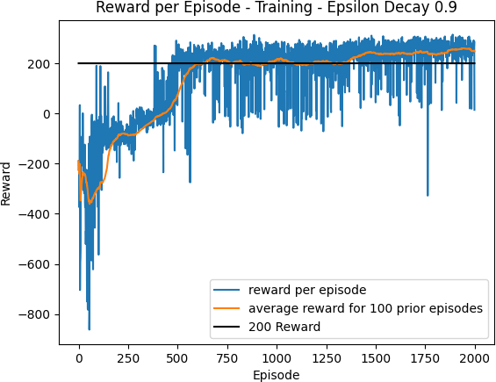
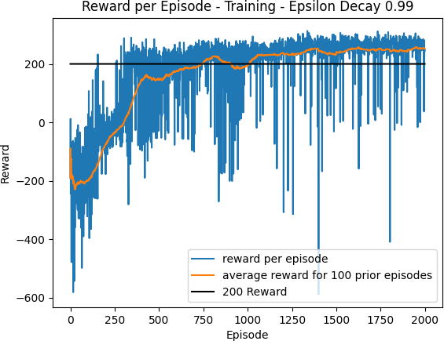
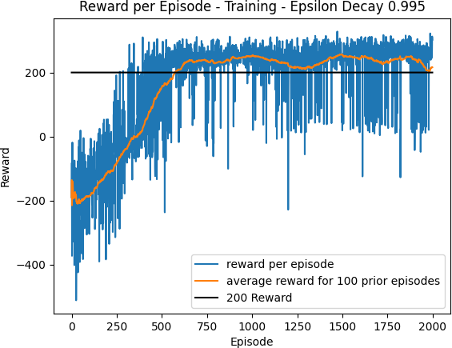
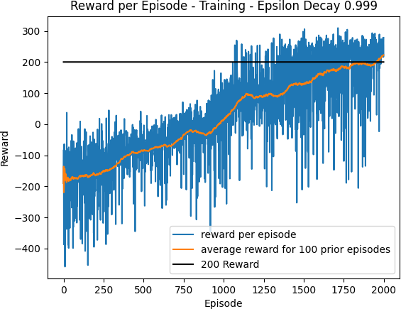
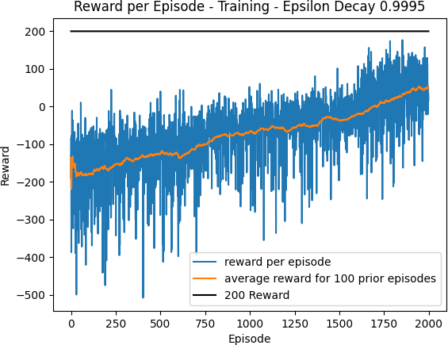
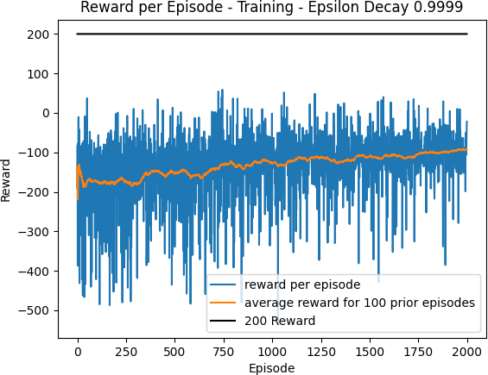

Figure 7: Epsilon Decay Optimization

As it can be seen in the plots above when the epsilon decay factor is too large (e.g. >=
.999) the agent is unable to meet the reward threshold after 2000 episodes. Even though the average reward is trending upward and will most likely reach the threshold eventually, the training is very slow due to the agent randomly exploring too much and not taking advantage of the experience learned through the neural network. It appears that the optimal epsilon decay factor is .995 and this will be the value used in further experiments.

Replay Buﬀer Size

As discussed earlier, the experience replay buffer is a fixed size buffer used to store the agent’s most recent state, action, reward, next state experiences. To train the model a minibatch of experiences are sampled uniformly at random from this buffer. Since this buffer is a fixed size, once the buffer reaches maximum capacity, the oldest experience is removed from the buffer and
replaced with the most recent experience. If the buffer is too small then the buffer will potentially not contain reward rich experiences that the network could benefit learning from. However if the buffer is too large, the buffer will contain many very old experiences that may not provide much learning value to the network. Below in figure 8 I show the result of training for varying replay buffer sizes using the optimal hidden layer size of 64 and optimal epsilon decay factor of.995 that were found previously.
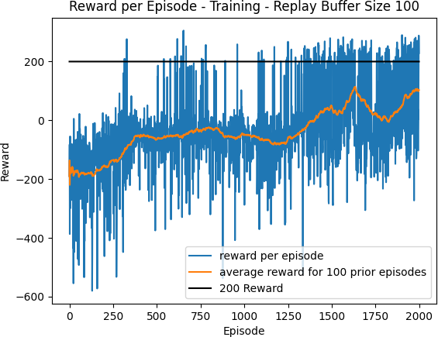
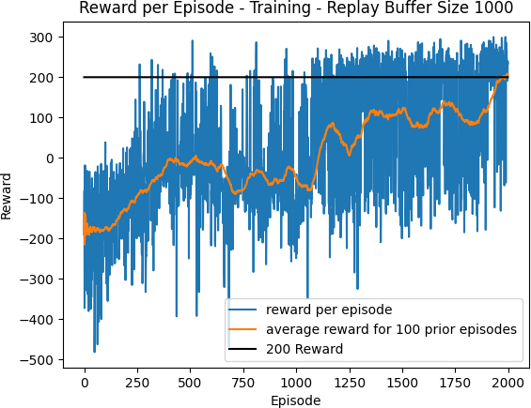
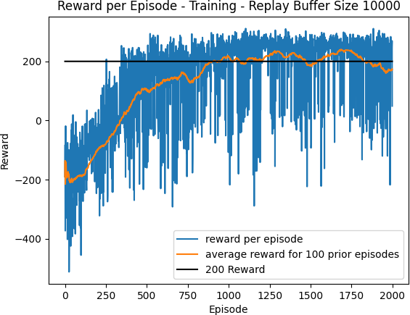
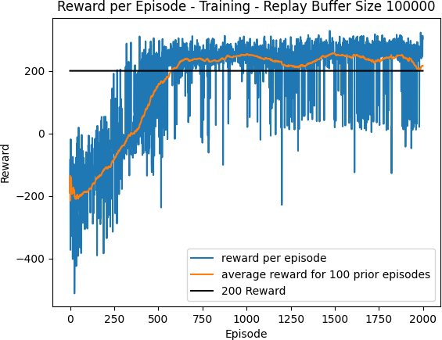
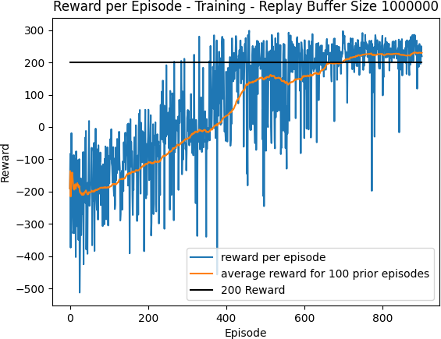
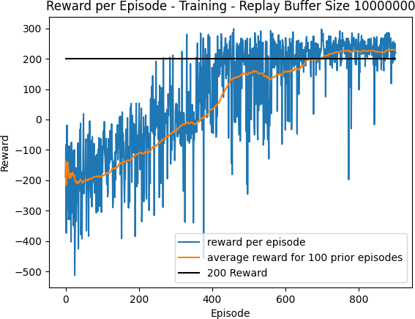

Figure 8: Replay Buffer Size Optimization

As it can be seen in the pilots below, when the buffer size is too small, the training takes many more episodes to converge due to the presence of too many correlated experiences in the buffer, and when the buffer size is too large the training is incredibly slow and inefficient due to the buffer containing too many old experiences. It is clear that the optimal replay buffer size is 10000. With this size the training converges around the 500th episode.

5: Results:
Based on the results of the hyperparameter optimization the final network was trained with the following hyperparameters - hidden

layer size (64), epsilon decay factor (.995), replay buffer size (100000). Below in figure 9 I show the result of training with these hyper- parameters.
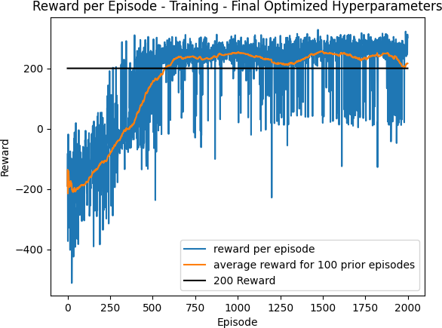

Figure 9: Training with Optimized Hyperparameters

With the optimized hyperparameters we can see that the training is both efficient and accurate. The agent is able to achieve the average reward threshold of 200 after about 500 episodes, and the performance remains relatively stable as it continues to train.
However in order to better evaluate the efficacy of the model I will now test the model on 100 consecutive episode where all actions are determines solely by the Q neural network that was trained. Below in Figure 10 we can see the results.

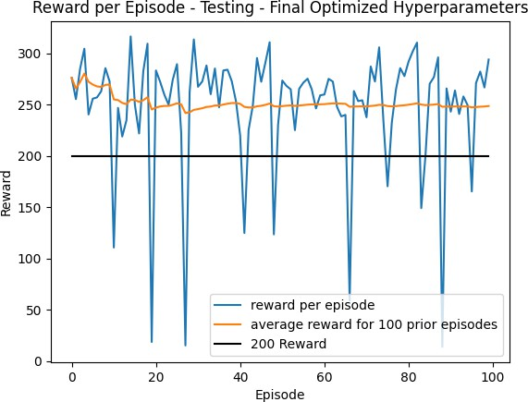

Figure 10: Testing with Final Qnet

In the plot above it can be seen that over 100 episodes 90 of those episodes achieved a reward of at least 200. Although there are 10 episodes that do not meet this threshold, this episodes still achieve a positive reward.

6: Discussion:
After optimizing three optimizers I was able to train a Qnet model that was able to achieve a 90% success rate in reaching the 200 reward threshold. There were many other hyperparameters that could have been trained, but due to computational and time constraints I was not able to optimize these and instead chose values that I thought were reasonable. If I had more time I would certainly perform a much larger gird search in order to optimize all hyperparameters. One of the major pitfalls I experienced was that I first attempted to tune hyperparameters without using experience replay. Initially I thought that even without experience replay I would be able to optimize a network to converge but the training was too unstable and I wasted a large amount of time doing this. Another method I would like try if I had more time would be to implement a more intelligent sampling of the replay buffer instead of using uniform random sampling.
Since the buffer is sampled randomly it is possible that many of the experiences samples for the minibatch are not reward rich and therefore don’t provide much learning value. I would like to try sampling such that experiences with more extreme rewards would be more likely to be samples in order to speed up training.

7: Conclusion:
Overall this project was a success. I was able to successfully train a DQN to solve the Lunar Lander problem, and in the process was able to better understand how sensitive Deep Q Networks are to hyperparameters.

8 References:
- Richard S Sutton and Andrew G Barto. Reinforcement learning: An introduction. 2nd Ed. MIT press, 2020. url: http:// incompleteideas.net/book/the-
book-2nd.html.
- Playing Atari with Deep Reinforcement Learning, Mnih et al.
- Human-level control through Deep Reinforcement Learning, Mnih et al.

